Instructions for Commenting and Voting in Edaptive

In the Edaptive Commenting Portal, under the quick monitor, there are a list of documents with assigned tasks. Click the link of the document that is undergoing Proposed Draft review and vote (Stage 50).

For voting members of the Document Development Committee (DDC), Expert Panel (ExP), Subcommittees (SC) and Primary/Alternate Delegates, a “Vote” button will appear at the top of the document (see image below). For non-voting DDC contributors or ExP and SC advisors, Board of Director members, or Consensus Council members, this box will not appear.

All individuals are asked to review the draft for scientific accuracy, practicality, comprehensibility, and overall quality and utility. Substantive comments can be submitted, however, avoid those of editorial nature and/or those relating to formatting style.

# 

# Adding a Comment

To add a comment on the draft:

1. Hover over the gear icon next to the section of text.
2. Select “Add Comment”.
3. Select the action type.
4. Select the comment type (“Editorial”, “Technical”, or “General”).
5. Select if the comment is supporting an affirmative or negative vote.
6. Add a justification or rationale for the comment.
7. Click “Submit”.

There are four action comment types:

* + **Modify Item:** Adding to, removing part of, or modifying existing content.

Commenters are encouraged to suggest wording changes.

* + **Insert Item:** Inserting new content to the document, above or below the selected location.
  + **Delete Item:** Removing a section of content all together.
  + **Other:** Notifying the DDC of comments that apply globally, such as a word change throughout the document or the addition of a new reference.

N**OTE:** Commenters can see all comments that have been made and should avoid adding duplicative comments.

# Overview of Editing Functions

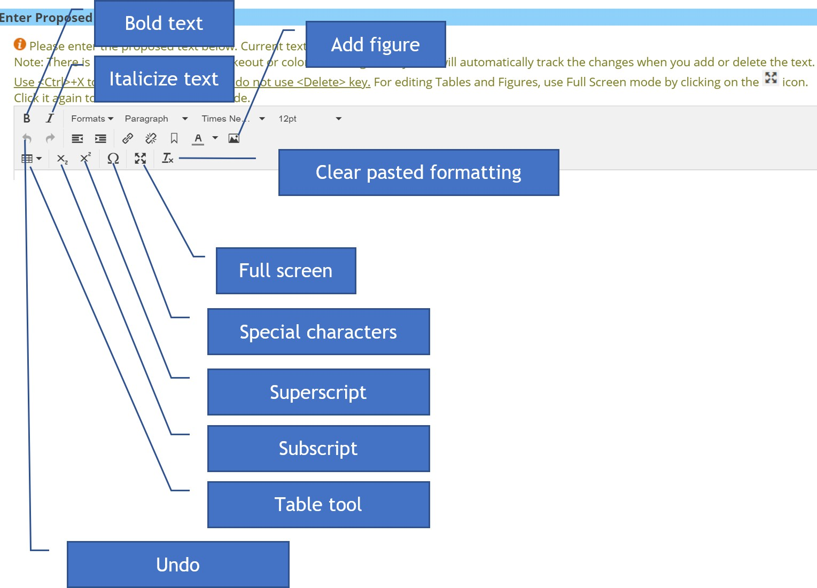

Modify Item

To modify an item:

1. Place the cursor where the change should be made. Use Ctrl + X or the backspace key to remove text. Red highlighted text is tracked as “removed” and green highlighted text is tracked as “added”.
2. Add a justification or rationale for the comment.
3. Select a category for the comment type (“Editorial”, “Technical”, or “General”).
4. Select a category for the vote (“Affirmative” or “Negative”), this applies to voting members only.
5. Click “Submit”.

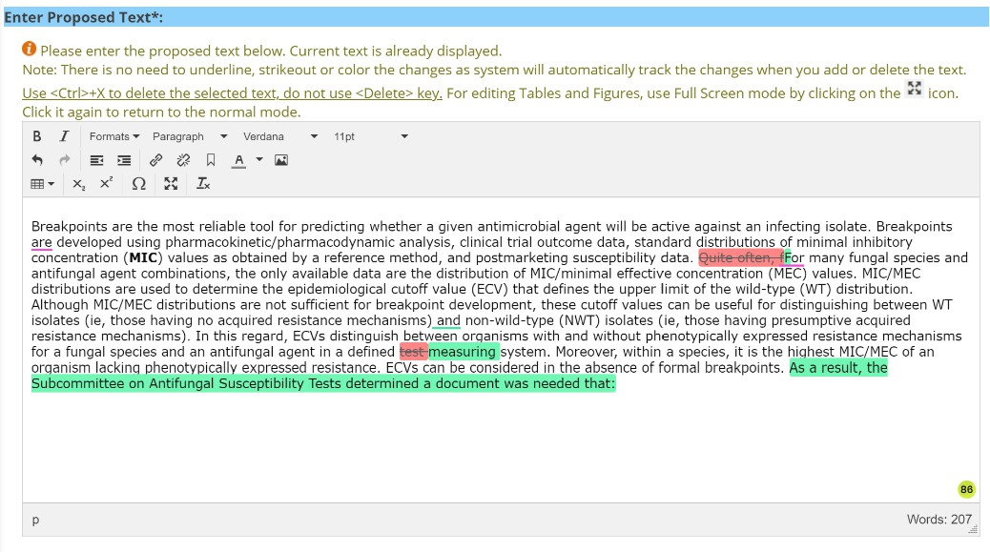

# Insert Item

To insert a new item:

1. Select the position of new content, above or below.
2. Add new content, if it is text, type the content, if it is an image:
   1. Select the **Image Icon**
   2. Select the image and click **Open**.
   3. The image can be resized by grabbing the boxes on one of the four corners.
3. The image file **MUST** be uploaded into the comment.
4. Add the justification or rationale for the new item.
5. Select a category for the comment type (“Editorial”, “Technical”, or “General”).
6. Select a category for the vote (“Affirmative” or “Negative”), this applies to voting members only.
7. Click **Submit.**

**NOTE:** Equations are added as images.

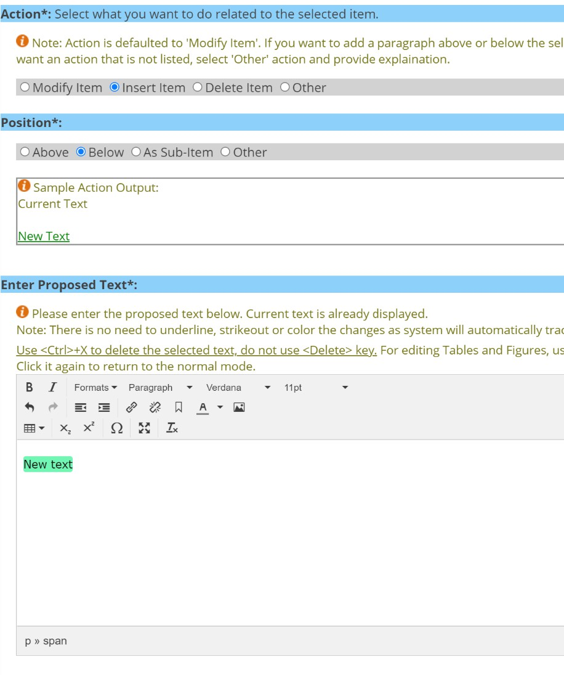

# Delete Item

To remove an entire section of content:

1. Select self to delete the entire section of text, select self and sub-items to select the entire section of texts and any corresponding sub-items.
2. Add the justification or rationale for the removal of the item.
3. Select a category for the comment type (“Editorial”, “Technical”, or “General”).
4. Select a category for the vote (“Affirmative” or “Negative”), this applies to voting

members only.

1. Click **Submit.**

**NOTE:** The text will be highlighted brown that will be removed.

# Other

Comments categorized as “Other” should be reserved for situations when a change needs to be made throughout the document, such as a wording change. It can also be used to add a new reference to a document.

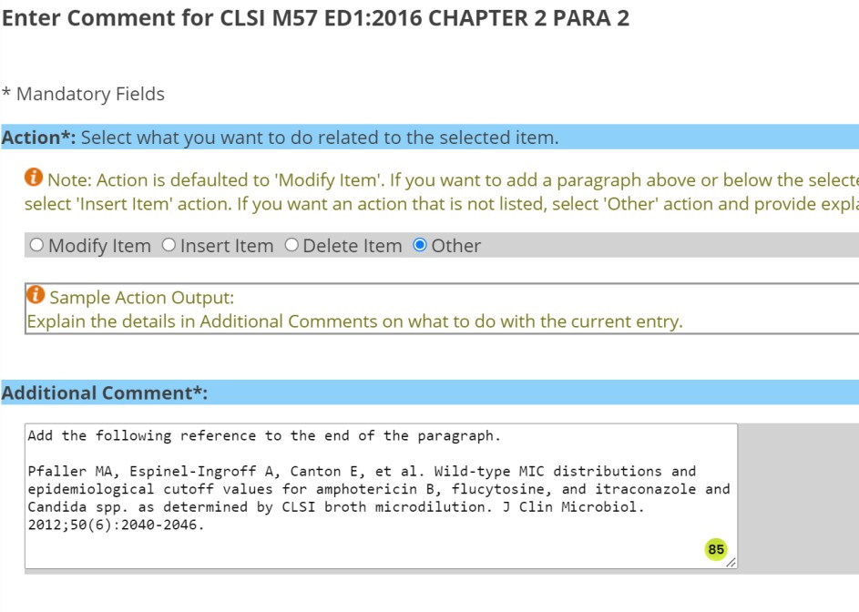

# Voting

To cast your vote, eligible voters should:

1. Click “Vote” in the box at the top of the document.
2. Ensure the review of the document is complete.
3. Select the appropriate voting option:
   1. Accept
   2. Accept with comments
   3. Reject with comments
   4. Abstain
4. Click “Vote”.

**NOTE:** If “Accept with comments” is selected, there needs to be comments marked as

“Affirmative” in the document. If “Reject with comments” is selected, there needs to be comments marked as “Negative” in the document.

