Instructions for Commenting in Edaptive

In the Edaptive Commenting Portal, under the quick monitor, there are a list of documents with assigned tasks. Click the link of the document that is undergoing Proposed Draft review (Stage 50).

All individuals are asked to review the draft for scientific accuracy, practicality, comprehensibility, and overall quality and utility. Substantive comments can be submitted, however, avoid those of editorial nature and/or those relating to formatting style.

# Adding a Comment

To add a comment on the draft:

1. Hover over the gear icon next to the section of text.
2. Select “Add Comment”.
3. Select the action type.
4. Select the comment type (“Editorial”, “Technical”, or “General”).
5. Add a justification or rationale for the comment.
6. Click “Submit”.

There are four action comment types:

**Modify Item:** Adding to, removing part of, or modifying existing content. Commenters are encouraged to suggest wording changes.

* + **Insert Item:** Inserting new content to the document, above or below the selected location.
  + **Delete Item:** Removing a section of content all together.
  + **Other:** Notifying the DDC of comments that apply globally, such as a word change throughout the document or the addition of a new reference.

N**OTE:** Commenters can see all comments that have been made and should avoid adding duplicative comments.

# Overview of Editing Functions

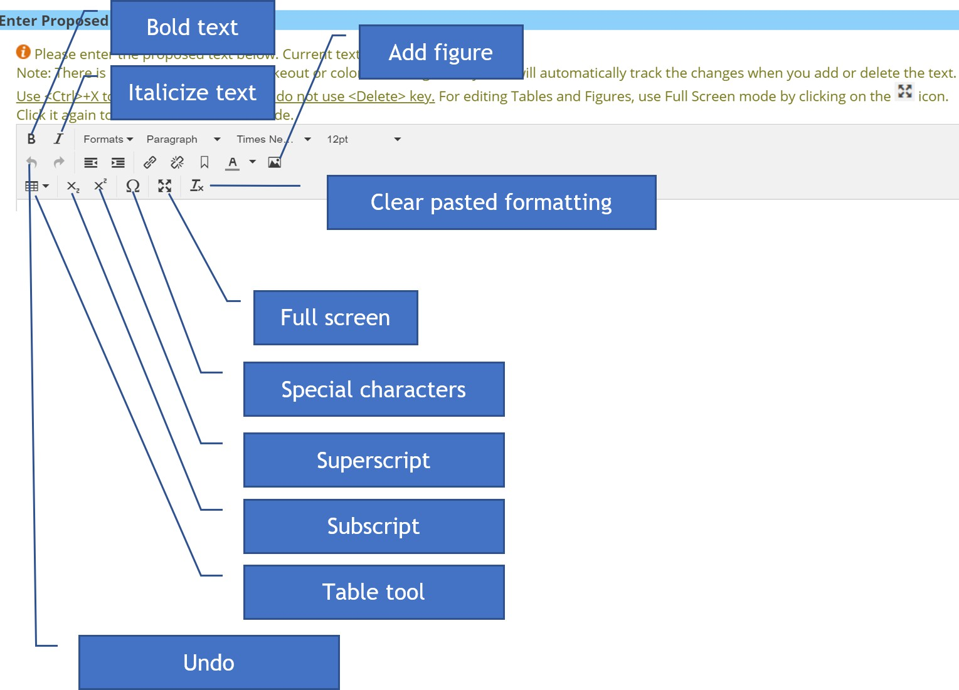

Modify Item

To modify an item:

1. Place the cursor where the change should be made. Use Ctrl + X or the backspace key to remove text. Red highlighted text is tracked as “removed” and green highlighted text is tracked as “added”.
2. Add a justification or rationale for the comment.
3. Select a category for the comment type (“Editorial”, “Technical”, or “General”).
4. Click “Submit”.

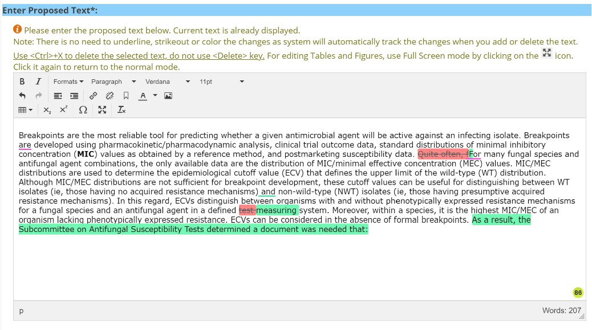

# Insert Item

To insert a new item:

1. Select the position of new content, above or below.
2. Add new content, if it is text, type the content, if it is an image:
   1. Select the **Image Icon**
   2. Select the image and click **Open**.
   3. The image can be resized by grabbing the boxes on one of the four corners.
3. The image file **MUST** be uploaded into the comment.
4. Add the justification or rationale for the new item.
5. Select a category for the comment type (“Editorial”, “Technical”, or “General”).
6. Click **Submit.**

**NOTE:** Equations are added as images.

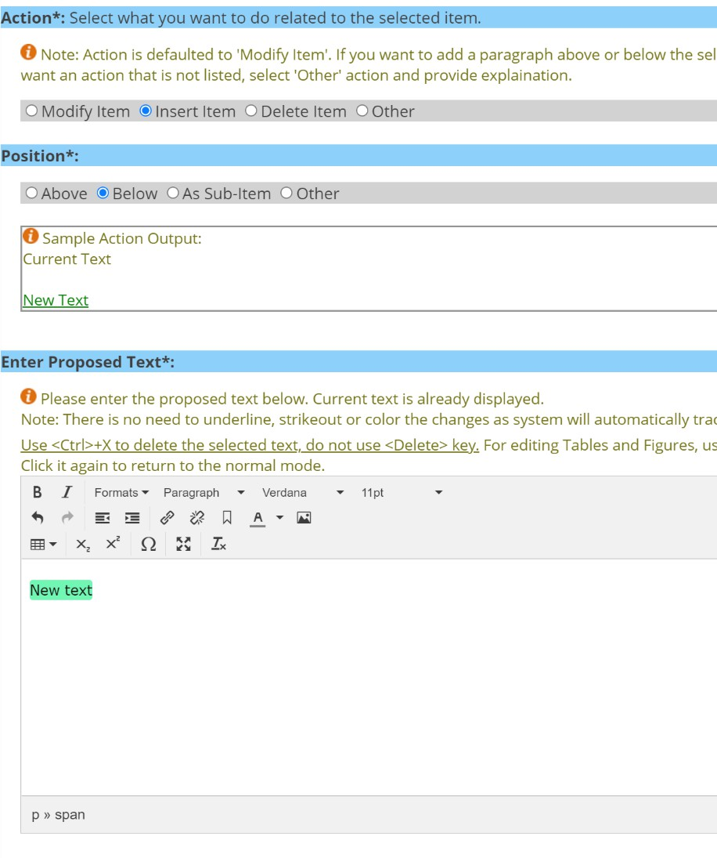

# Delete Item

To remove an entire section of content:

1. Select self to delete the entire section of text, select self and sub-items to select the entire section of texts and any corresponding sub-items.
2. Add the justification or rationale for the removal of the item.
3. Select a category for the comment type (“Editorial”, “Technical”, or “General”).
4. Click **Submit.**

**NOTE:** The text will be highlighted brown that will be removed.

# Other

Comments categorized as “Other” should be reserved for situations when a change needs to be made throughout the document, such as a wording change. It can also be used to add a new reference to a document.

